

KIRINYAGA CENTRAL TECHNICAL AND VOCATIONAL COLLEGE
P.O. BOX 205-10300 KERUGOYA KENYA
TELEPHONE: +254 721-624666
E-mail: kirinyagacentraltvc@gmail.com
ADMISSION FORM ADM.NO………………………………...

DATE.…………………………………………….
NAME: …………………………………………………………………………………………………
ADDRESS………………………………………………………………………………………………
YEAR OF ADMISSION………………………… COUNTY…………………………………………
DEPARTMENT……………………………………………………………………………………….
COURSE ADMITTED TO…………………………………….……………………………………….
Duration……………………………..
Following your application for a course at this college, I am glad to communicate that you were successful and you have been admitted to undertake the above mentioned course.

Please report for admission on ………………. but not later than ………….… during working hours.

The college is located on Mukinduri - Kiamuthambi Road, Kirinyaga Central Sub-County, Kirinyaga County. It is about 4km from Kerugoya Town.

GENERAL INFORMATION
- The following documents will be required during admission
- Copy of Birth Certificate and Identification Card (ID)
- Copy of KCPE Certificate and KCSE Certificate/Result Slip,
- Copy of School Leaving Certificates
- Three passport size photographs recently taken
- Medical Certificate . A blank Medical Examination form is enclosed. This should be duly filled by a Doctor in a Government Hospital.
- A duly filled Application Form
- Duly filled Joining Instructions
- Banking Slip

- When reporting, you should bring originals of Certificates or Result slip, National Identity card, Birth Certificate and School-leaving certificates for identification, to be given back after verification.
- Training Materials- Trainees are required to buy a REAM of Printing papers, their own stationery e.g. notebooks, exercise books or foolscaps. Each Course has different training materials that the trainees will be required to purchase. The list will be provided upon admission.
- Examinations- There will be both Internal and External Examinations. The internal examinations should be taken seriously by all trainees. External Examination will be set by TVET-CDACC, NITA and KASNEB among other examining bodies.
- College Rules and Regulations –Rules and Regulations to be observed by all trainees as basis for harmonious coexistance fundamental in pursuit for both training and learning. All trainees are required to familiarize themselves with the same and adhere to them strictly ,failure to which appropriate disciplinary action will be taken.
- Trainees, Parents/Guardians Record Form- A blank form for trainees is enclosed. Please read it thoroughly and fill in the blanks as comprehensively as possible and sign the relevant areas accordingly.
We look forward to meeting you on the above specified date and wish you a successful training with us.

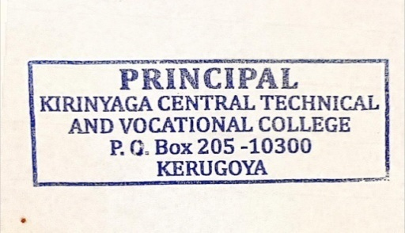

Charity N. Muthoni
PRINCIPAL

